**Institute of Technology Tralee**

**Ord/Hons BSc. in Computing with Specialism (Groups 3+4) - Year 1**

**Continuous Assessment #1**

**Date: 18/2/14**

**Time: 3 – 4.30 p.m.**

**Object Oriented Programming 1**

**Instructions:** Attempt the following question. You should use the JCreator IDE. When you are finished coding, print out your code in **landscape** format.

**________________________________________________________**

**Q1.**

In computer networking, all 32-bit IP address contain 4 octets, which are sequences of 8 bits. In decimal, a valid octet will be a number between 0 and 255 inclusive. Therefore a valid octet will

* Contain between 1 and 3 characters inclusive
* Contain digits for all of its characters
* Be such that the octet string, when converted to an integer, describes a whole number value between 0 and 255 inclusive

You must write a Java program where the user is firstly asked to enter a value for an octet in the main(). The main() then calls a user-defined method **validOctet**() which takes, as a String argument, the octet entered and attempts to validate it based on the criteria outlined above. validOctet() shouldreturn a boolean true or false result to main() when it has completed its validation. When the boolean value has been returned to main(), then the main() itself should display a message dialog to indicate whether or not the octet entered by the user was valid.

For full marks here your program should, along with a logically correct solution for the problem above, include the usual **single-line** and **multi-line comment** at the top of the program. The multi-line comment should briefly explain the purpose of the program.

Your program should run as indicated in the following sample screenshots. You should use the values indicated in the screenshots when testing your program.

**Sample Screenshots**

**Run 1 – The user enters “12x” for the octet**

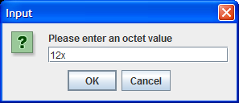 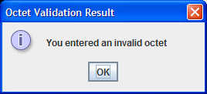

**Run 2 – The user enters “1234” for the octet**

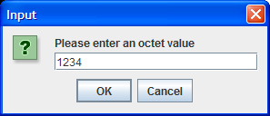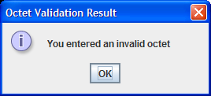

**Run 3 – The user enters “256” for the octet**

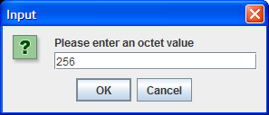

**Run 4 – The user enters “228” for the octet**

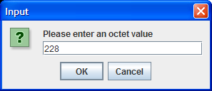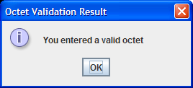

**Run 4 – The user enters “7” for the octet**

